

**Expat Counter**

**Third-country nationals**

Reporting and registering as an expat in the City of Ghent

Version 7 February 2022

Content

Who can the Expat Counter help? 3

Stay of maximum 90 days (short stay) 4

How to apply for a Declaration of Arrival? 4

Stay exceeding 90 days (long stay) 5

How to register? 5

Validity period of the A card 8

Change of status 10

Other expat residence procedures 11

What to do when leaving Belgium on a temporary or permanent basis? 11

Reporting a lost, stolen or damaged residence document 11

Who to contact? 12



***This text contains links to information pages and examples of residence documents (indicated by an Internet icon in the margin).***

Who can the Expat Counter help?

The Expat Counter is intended for persons who do not have the Belgian nationality, have their main place of residence in Ghent and are labour migrants in accordance with the Residence Act. Labour migrants are in possession of a work permit, Annex 46/47 (granting a single permit), a hosting agreement or a professional card and work in Belgium on a temporary basis as knowledge workers (researchers, visiting professors, trainees, high-skilled staff, executives, etc.), athletes (or attendants) or stage artists (or attendants).

The expat must reside in Ghent at the time of registration. Applications submitted before the expat’s arrival will not be processed.

The expat’s relatives can register **simultaneously** at the Expat Counter provided that they have a type D visa (EU / EEA citizens and Swiss nationals do not require a type D visa), have their main place of residence in Ghent and submit the required documents.

Relatives who do not register simultaneously with the expat must register at the regular counter.

The Expat Counter processes the residence application faster than the regular counter thanks to registration by e-mail, faster residence check, etc. Expats can also initiate their residence procedure at the regular counter. Once made, their decision is final.

The Expat Counter currently does not handle any applications for renewal of the residence card.

The procedure varies depending on the expat’s nationality. This brochure deals with expats who are **not** citizens of the European Union, EEA citizens or Swiss nationals.

The expat will receive an invitation to go to the counter. Expats who reside in the centre of Ghent have to report to the Expat Counter in the EGW building (former library, next to the former AC Zuid). Expats who reside in one of the submunicipalities have to report to the local service centre (dienstencentrum).

# Stay of maximum 90 days (short stay)



Third-country nationals with a type C visa, exempted from type C visa requirements or with a residence card from a Schengen Member State who will be working and residing in the Schengen area for **maximum 90 days** have to request a [**Declaration of Arrival (aankomstverklaring) (Annex 3)**](https://dofi.ibz.be/sites/dvzoe/NL/Documents/bijlage_03.pdf).

This is not required for expats staying at a hotel. The hotel will report their presence.

Holders of a type D visa can also request a Declaration of Arrival if they waive their type D visa.

This registration procedure does not result in relocation of their main place of residence (domicile) to Belgium.

## How to apply for a Declaration of Arrival?

The expat's contact has to send an e-mail to [expats@stad.gent](mailto:burgerzaken.expats@stad.gent) within 3 working days from the expat's arrival in Belgium. This registration e-mail contains the following information:

* subject: Annex 3
* expat's surname and given names
* expat’s nationality
* correct and complete residence address in Ghent
* duration of employment in Belgium

Include a scan of:

* + valid passport
  + valid visa (only for third-country nationals requiring a visa) or residence card of a Schengen Member State (valid for the duration of the stay in Belgium)
  + 1 recent passport photograph

Later on, the expat will receive an invitation by e-mail from their contact to make an appointment to submit the required documents.



The expat should bring the following to the appointment:

* valid passport
* valid visa (only for third-country nationals requiring a visa) or residence card of a Schengen Member State (valid for the duration of the stay in Belgium)
* correct and complete residence address
* 1 recent passport photograph that meets the [quality criteria](http://www.ibz.rrn.fgov.be/fileadmin/user_upload/nl/kaarten/eid/documentatie/2016_Matrice_NL.pdf)

The Declaration of Arrival costs € 13 and can be paid in cash or by card.

# Stay exceeding 90 days (long stay)

Third-country nationals who will be working and residing in Belgium for more than 90 days must apply for a type D visa at the competent diplomatic mission.

In most cases, possession of Annex 46/47 (granting a single permit), a hosting agreement or a professional card is a requirement for obtaining a type D visa.

You can find more information about the application for a type D visa on the [website of the Immigration Office](https://dofi.ibz.be/sites/dvzoe/NL/Gidsvandeprocedures/Pages/Om_te_werken.aspx).

Expats who hold a type D visa but do *not want to stay for more than 90 days* can also opt for a short-stay application procedure.

They will receive a *Declaration of Arrival (Annex 3).*

## How to register?

Holders of a type D visa can travel to Belgium. The expat does not have to come in person, they may register through e-mail.The expat's contact has to send an e-mail to [expats@stad.gent](mailto:burgerzaken.expats@stad.gent) within 8 days from the expat's arrival in Belgium. This e-mail contains the following information:

* surname and given names
* nationality
* country and city of residence prior to their arrival in Belgium
* date of arrival in Belgium
* correct and complete residence address in Ghent
  + duration of employment in Belgium
  + telephone number and times when the expat is at home so that the residence check can be performed by a community police officer.

Include a scan of:

* valid passport
* valid type D visa
* 1 recent passport photograph
* letter with decision by the Department of Economic Migration and Annex 46/47

**or** professional card

**or** proof of employment (possibly employer certificate or hosting agreement)

The expat’s contact will receive a registration confirmation e-mail when the file is opened.

The e-mail will have the Annex 49 (without indication of the national register number)attached. With this document the expat can start working.

In case the expat has a hosting agreement or a professional card, they can receive an annex 15. This is a temporary residence document pending the residence card

A community police officer will check the expat’s residence afterwards. On average, this residence check is performed within three weeks from the application.

If the community police officer does not find the expat at their residence address, he/she will drop a residence check card in the letterbox. In that case, please contact the community police officer as soon as possible.



It is important to arrange for adequate housing prior to initiating the registration procedure. If the expat does not have a residence address for at least two months, it is best to postpone the registration procedure.

Expats should put their name on the doorbell and the letter box in a clear manner so as to make it easier for the police to perform residence checks.



The authorized community police officer can be found on<http://www.lokalepolitie.be/5415/contact/je-wijk>.

A positive residence check is followed by registration in the foreign nationals register. If the residence check is negative, the registration application will be rejected. The expat’s contact will be informed by e-mail.

As soon as the positive police report has been processed, the Expat Counter or the competent service centre will invite the expat by e-mail to complete the registration and to apply for the type A electronic residence card. Pending the issuance of the A card, the expat will receive a new annex 49 (this time with indication of the national register number).

*The A card is a biometric card. This means that fingerprints and signatures are registered electronically. When the expat comes to collect the card, their fingerprints will be compared to the previous prints to make sure it concerns the same person.*



When applying for the A card, the expat will submit the following:

* valid passport
* valid type D visa
* Annex 46/47 (granting a single permit)

**or** if applicable: professional card

**or** proof of employment (employer certificate or hosting agreement)

* foreign driving license: if issued by an EEA Member State
* if applicable, sworn translation of the expat's birth certificate (legalised or endorsed with an apostille if required)
* personal invitation e-mail
* 25 EUR (fee for the A card)
* 1 recent passport photograph that meets the [quality criteria](http://www.ibz.rrn.fgov.be/fileadmin/user_upload/nl/kaarten/eid/documentatie/2016_Matrice_NL.pdf)

***The personal invitation e-mail always lists the documents required as this may vary per application. It is therefore important to read this list carefully!***

The A card can be collected once the expat has received the PIN / PUK codes. The A card can only be collected at the office that issued it.

[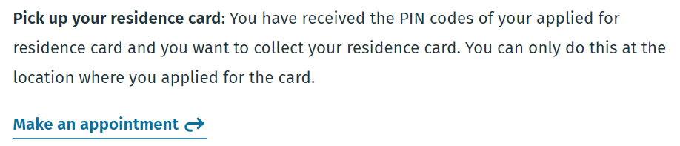](https://stad.gent/nl/burgerzaken/online-afspraak-maken/online-appointments-migration-counter-or-service-centre)The expat will need to make [an appointment](https://stad.gent/nl/burgerzaken/online-afspraak-maken/online-appointments-migration-counter-or-service-centre) to collect the residence card.

When collecting the A card, the expat should bring:

* provisional residence document (Annex 49 or Annex 15)
* PIN/PUK codes

The type A electronic residence card looks like this:

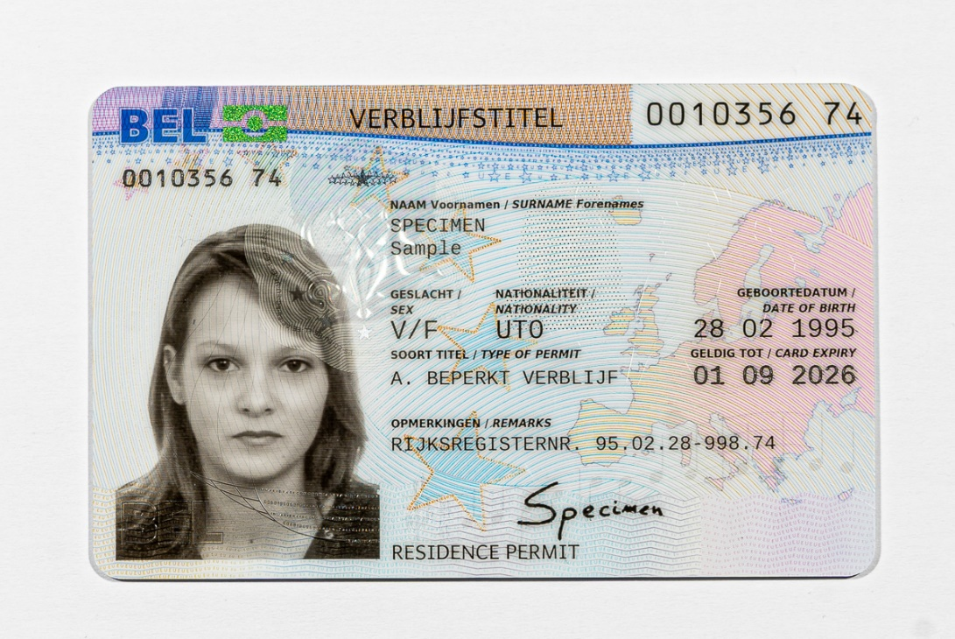

## Validity period of the A card

In case of an application for a single permit, the residence card is valid for the duration of employment in Belgium. In other cases, the card is valid for the duration of employment plus a short additional period, if applicable.

An A card can be renewed provided that the expat in question has met the applicable residence conditions throughout the stay.

The employer applies for renewal of the single permit with the competent regional authorities. The application has to be submitted the latest two months before expiry of the residence card. In view of the long period of processing by the Immigration Office in Brussels, it is advisable to submit the application approximately four months before expiry of the residence card.

In case the expat has a hosting agreement (exemption single permit) or a professional card, a new A card can be applied for at the earliest 45 days and at the latest 30 days prior to the end of the current A card’s validity. Expats with a hosting agreement or a professional card can apply for a renewal of the A card by completing the [e-form.](https://stad.gent/nl/burgerzaken/migratie-integratie/e-form-different-online-applications)

*Always report any* ***change of address*** *immediately to the Migration Counter or to a service centre (****even if the residence card is still valid****). Any failure to do so can result in the expat being removed from the foreign nationals register. If this happens, the residence card will become invalid and the expat may lose the right of residence. The expat must then request a re-registration, but the investigation of such an application may take a long time. This means a new residence card cannot be obtained right away.*

*Also report a change of address immediately to the new municipality in case you move out of Ghent.*



The expat will receive a receipt if all conditions of admissibility have been met and if the residence check has had a positive result. This is not a residence document.

In case of a positive decision, the expat will obtain a type A electronic residence card.

## 

Change of status

**Expats with a hosting agreement** or **a professional card** who have the right to reside in Belgium for a short period of time (because they hold a type C visa or are exempt from visa requirement) or for a longer period of time (e.g. student residence permit) can apply for residence as a labour migrant through a change of status.

*A change of status is* ***not advisable as an alternative*** *to applying for a* ***type D visa*** *because:*

* *the conditions of admissibility are very strict: if the residence check is negative, for instance, the application will be rejected;*
* *there is no legal deadline to approve the application for a change of status. Consequently, it may take a long time before a decision is made;*
* *approval can never be guaranteed.*

**A change of status is only possible via the regular Migration Counter or competent service centre by** [**appointment**](https://afspraken.gent.be/product=1099)**.**

[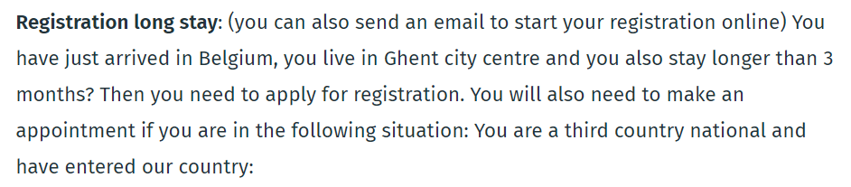](https://afspraken.gent.be/product=1099)

A change of status is only possible if the expat presents all the required documents during the **period of legal residence**!

The expat will submit the following documents:

* valid passport
* valid visa (only for third-country nationals requiring a visa) or residence card of a Schengen Member State (valid for the duration of the stay in Belgium)
* professional card
* criminal record certificate issued by the country of last residence which is no more than six months old at the time of the residence application and legalised or endorsed with an apostille, if applicable
* standard medical certificate
* proof of payment of the residence application fee: 366 EUR – BE57 6792 0060 9235 – reference: Surname First name Nationality DDMMYYYY. For exceptions and exemptions, please check out the website of the [Immigration Office](https://dofi.ibz.be/sites/dvzoe/NL/nieuws/Pages/De_bijdrage.aspx).
* letter of motivation (reference is required to art. 9 paragraph 2 of the Residence Act + art. 25/2 of Royal Decree on Residence)

*If one of the documents is not provided, the expat must explain why this is the case in the letter of motivation. A change of status can be requested, but the Immigration Office in Brussels will only make a decision when the file is complete.*

# Other expat residence procedures

There are additional residence procedures to obtain the expat status (e.g. in case of exceptional circumstances (article 9bis of the Residence Act), EU blue card, long-term resident, cross-border employment).

Further information can be obtained from the Migration Information Centre (Infopunt Migratie).

# What to do when leaving Belgium on a temporary or permanent basis?

Expats who are temporarily or permanently moving to another country must report their departure to the Migration Counter or competent service centre.



Click [here](https://stad.gent/nl/burgerzaken/migratie-integratie/niet-belgen/departure-belgium) for more information

# Reporting a lost, stolen or damaged residence document

If a registration document is lost, stolen or damaged, the expat must notify the police immediately (not the Migration Counter or service centre). The police will issue a certificate (Annex 12) to confirm that the loss, theft or destruction has been reported.

In addition, the expat should have their registration document blocked through Doc Stop (0800 2123 2123).

Finally, the expat must request a duplicate of the registration document from the municipality. The municipality will first check the data in the national register and the passport photograph. The duplicate has the same expiry date as the original residence document.

Who to contact?

**Loket Expats (Expat Counter)**

**phone**: 09 266 71 50

**e-mail**: [expats@stad.gent](mailto:expats@stad.gent)

**visit**: by appointment

**Make an online appointment:** <https://stad.gent/nl/burgerzaken/online-afspraak-maken/online-appointments-migration-counter-or-service-centre>

**accessibility and opening hours**: <https://stad.gent/nl/openingsuren-adressen/dienst-burgerzaken-loket-migratie-expats>

*OR*

[www*.*stad.gent](http://www.stad.gent) > zoeken > Expats

**Infopunt Migratie (Migration Information Centre)**

**phone**: 09 266 71 40

**e-mail**: [infopuntmigratie@stad.gent](mailto:infopuntmigratie@stad.gent)

**visit**: by appointment

**Make an online appointment:** <https://stad.gent/nl/burgerzaken/online-afspraak-maken/online-appointments-migration-information-centre>

**accessibility and opening hours**: <https://stad.gent/nl/openingsuren-adressen/dienst-burgerzaken-infopunt-migratie>

*OR*

[www*.*stad.gent](http://www.stad.gent) > zoeken > Infopunt Migratie

Published by: Mieke Hullebroeck - Managing Director - City Hall, Botermarkt 1, 9000 Ghent

**Dienstencentra (Service Centres)**

**accessibility and opening hours**:

<https://stad.gent/nl/openingsuren-adressen/trefwoord/dienstencentra>

*OR*

[www*.*stad.gent](http://www.stad.gent) > zoeken > Dienstencentra

**visit:** by appointment

**Make an online appointment:** <https://stad.gent/nl/burgerzaken/online-afspraak-maken/online-appointments-migration-counter-or-service-centre>

Questions about a **work permit, employment permit or professional card?**  
Contact the **Department of Economic Migration** of the Flemish Government:

Koningin Maria Hendrikaplein 70 bus 60  
9000 Gent (Ghent)  
**phone:** 09 276 18 50  
**e-mail:** [arbeidskaart.gent@vlaanderen.be](mailto:arbeidskaart.gent@vlaanderen.be)